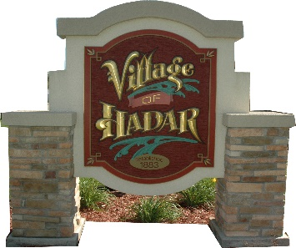
VILLAGE OF HADAR
PO Box 185 * 103 W. Main Street
Hadar, NE 68738

NOTICE IS HEREBY GIVEN, that a meeting of the Chairman& Trustees of the Village of Hadar, Nebraska will be held at 6:30 p.m. on Monday, March 11th 2024 at which the meeting will be open to the public. An agenda for such meeting is kept continuously current and is available for public inspection at the office of the Village Clerk. Except for items of an emergency nature, the agenda shall not be enlarged later than twenty-four hours before the scheduled commencement of the meeting.

Agenda Items to Date
Department Updates

New Business
Hadar Ridge Estates Yearly Fees
Sewer
Guard rails
Dog registration fees
Personnel

VILLAGE CLERK

_______________________
402 379-1720 (Please leave a message)

NOTICE: Council Meetings Are Now Being
Held At 103 W. Main Street (Old Hadar Fire Hall)
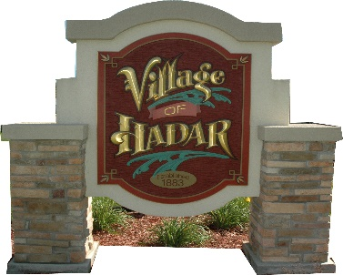
VILLAGE OF HADAR
PO Box 185 * 103 W. Main Street
Hadar, NE 68738

NOTICE IS HEREBY GIVEN, that a meeting of the Chairman & Trustees of the Village of Hadar, Nebraska will be held at 6:30 PM on Monday, March, 11th 2024 at which the meeting will be open to the public. An agenda for such meeting is kept continuously current and is available for public inspection at the office of the Village Clerk. Except for items of an emergency nature, the agenda shall not be enlarged later than twenty-four hours before the scheduled commencement of the meeting.
Agenda Items to Date
Department Updates

New Business

Hadar Ridge Estates Yearly Fees
Sewer
Guard rails
Dog registration fees
Personnel

VILLAGE CLERK

_______________________
402 379-1720 (Please leave a message)

COPY

NOT PART OF NOTICE

I certify that the above notice was posted by me in six public places in the Village as follows:

□ Hadar Elevator □ K & C Grain
□ Hadar Country Store □ Lutz Embroidery
□ Hometown Auto Repair □ www.thevillageofhadar.com
□ Hadar Community Building □ Lutz Embroidery

At 3:05 PM, on March, 4th 2024.

(Seal)
VILLAGE CLERK

____________________________

