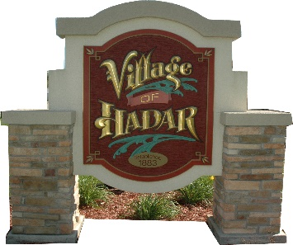
VILLAGE OF HADAR
PO Box 185 * 103 W. Main Street
Hadar, NE 68738

NOTICE IS HEREBY GIVEN, that a meeting of the Chairman& Trustees of the Village of Hadar, Nebraska will be held at 6:30 p.m. on Monday, January 8th 2024 at which the meeting will be open to the public. An agenda for such meeting is kept continuously current and is available for public inspection at the office of the Village Clerk. Except for items of an emergency nature, the agenda shall not be enlarged later than twenty-four hours before the scheduled commencement of the meeting.

Agenda Items to Date
Department Updates

New Business
Board Positions
Approve Vendors SO2 2024
Approve to go out for Insurance quotes

VILLAGE CLERK

_______________________
402 379-1720 (Please leave a message)

NOTICE: Council Meetings Are Now Being
Held At 103 W. Main Street (Old Hadar Fire Hall)
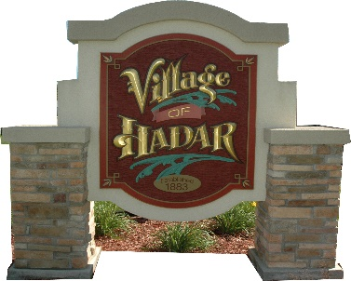
VILLAGE OF HADAR
PO Box 185 * 103 W. Main Street
Hadar, NE 68738

NOTICE IS HEREBY GIVEN, that a meeting of the Chairman & Trustees of the Village of Hadar, Nebraska will be held at 6:30 PM on Monday, January, 8th 2024 at which the meeting will be open to the public. An agenda for such meeting is kept continuously current and is available for public inspection at the office of the Village Clerk. Except for items of an emergency nature, the agenda shall not be enlarged later than twenty-four hours before the scheduled commencement of the meeting.
Agenda Items to Date
Department Updates

New Business

Board Positions
Approve Vendors SO2 2024
Approve to go out for Insurance quotes

VILLAGE CLERK

_______________________
402 379-1720 (Please leave a message)

COPY

NOT PART OF NOTICE

I certify that the above notice was posted by me in six public places in the Village as follows:

□ Hadar Elevator □ K & C Grain
□ Hadar Country Store □ Lutz Embroidery
□ Hometown Auto Repair □ www.thevillageofhadar.com
□ Hadar Community Building □ Lutz Embroidery

At 11:35 AM, on December, 30th 2023.

(Seal)
VILLAGE CLERK

____________________________

